**System Programming with BASH**

**BASH – Shell Functions**

  

**Before You Start**

* This exercise assumes that the user is working with the Ubuntu 18.04 distribution. If you are working with a different Linux distribution, the set of shell commands may vary from those available in Ubuntu 18.04.
* All commands and code discussed in this exercise will run in the Ubuntu console.
* The directory path shown in screenshots may be different from yours.
* Some steps are not explained in the tutorial**.** If you are not sure what to do:
  1. Consult the resources listed below and experiment in the Ubuntu console and try to solve the problem yourself.
  2. If you cannot solve the problem after a few tries, ask a TA for help.

**Learning Outcomes**

Students will be able to:

* Define functions in the shell
* Define functions in the file
* Use functions in the file

**Resources**

# Linux command line: bash + utilities

<https://ss64.com/bash/>

* Nano/Basics Guide

<https://wiki.gentoo.org/wiki/Nano/Basics_Guide>

**Preparation**

1. Connect to your Ubuntu instance

Open a command prompt

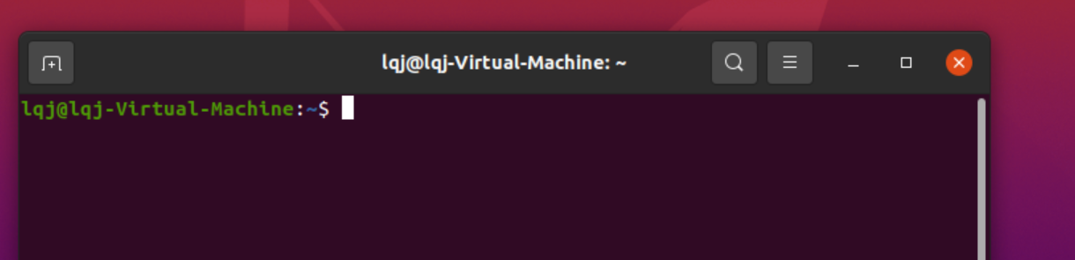

1. Navigate to your home directory

>>> cd ~

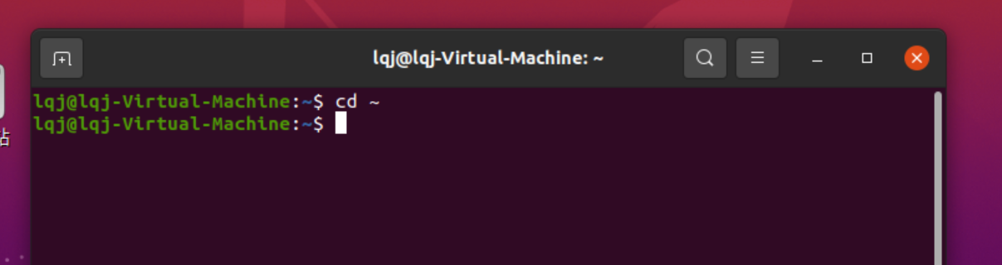

1. Create a directory named: Lab_b_BASH_Shell_Functions

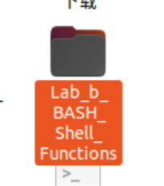Note: If this directory exists, skip this step.

>>> mkdir Lab_b_BASH_Shell_Functions

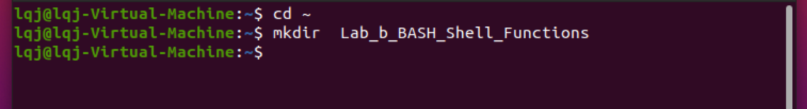

1. Navigate to the directory.

>>> cd Lab_b_BASH_Shell_Functions

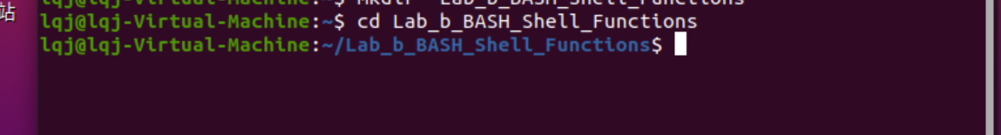

**Define a function in the shell**

1. The bash supports three different syntaxes for defining a function:

* function name <compound command>
* name() <compound command>
* function name() <compound command>

In this module, we will use the second syntax.

1. Define a function in the shell by typing the following command:

>>> circleArea() ( area=`echo "3.1415926 * $1 * $1" | bc -l`; printf "The circle's area is %s\n" "$area" )

Note: the script uses the bc command to calculate float numbers. The syntax is variable=`echo “formula” | bc -l`



1. Test the script by typing the following commands:

>>> circleArea 12

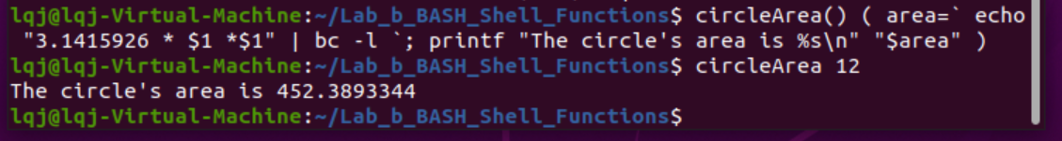

1. You can save the print result to a variable for future usage. Try it by typing the following commands:

>>> info=$( circleArea 5 )

>>> echo $info

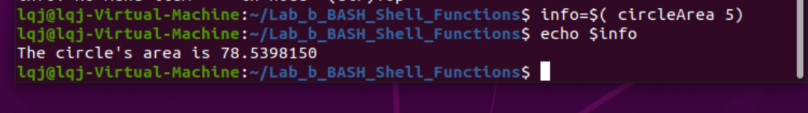

Note: you can use this method to get a return value from a function

1. The function also can return an exit code (0 - 255). Test it by typing the following commands:

>>> getNumber() ( return $(( $RANDOM * 255 + 1 )) )

>>> getNumber

>>> echo $?

>>> getNumber

>>> echo $?

>>> getNumber

>>> echo $?

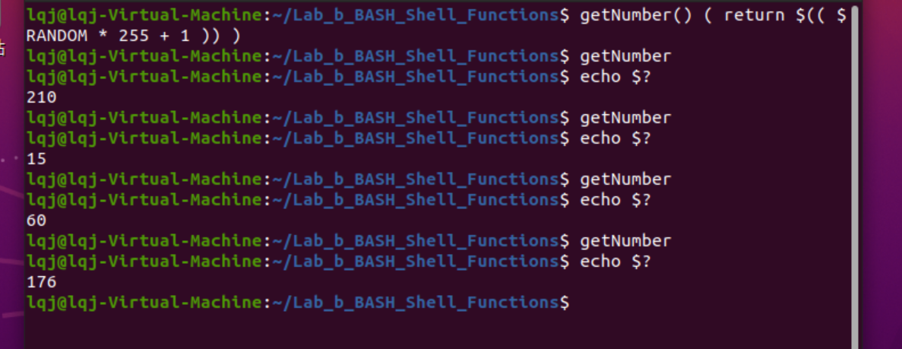

Note: The $? represents the last exit code which we returned from the function. You are supposed to see different numbers since our function returns a random number every time it is executed.

**Define a function in the file**

1. Functions defined in the shell will lose after you close the shell. It is good to write your functions in the file for the reusability

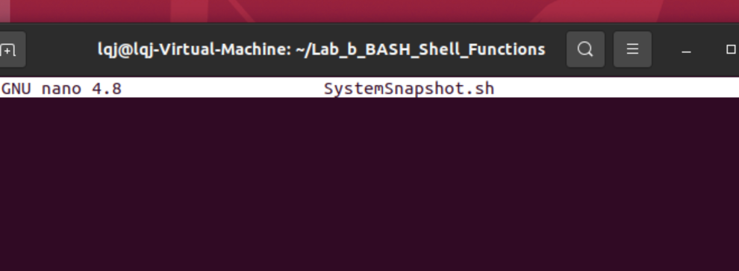

1. Create a script file by typing the following command:

>>> nano SystemSnapshot.sh

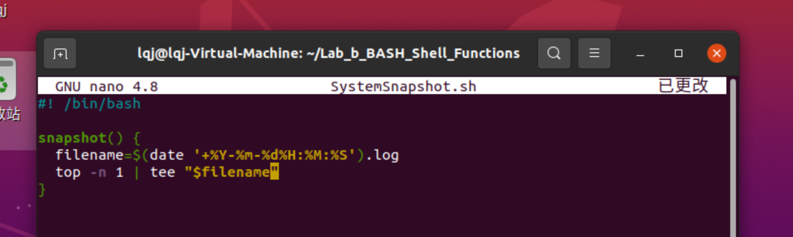

Note: we define a function called snapshot to take a system snapshot by running top command and save the information to a file with the name contains date and time that snapshot was taken.

1. Hit the control + x key to quit and save the file.

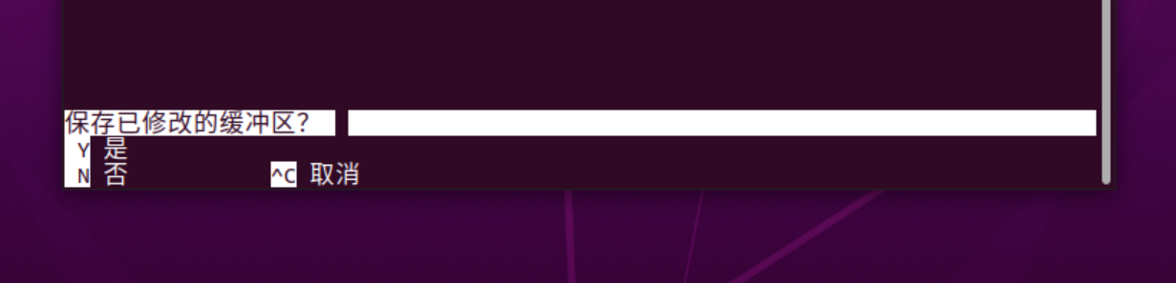

1. Before we can use the function that defines in a file, we have to source in the file in the current shell, making functions available to the shell. Run the following command to source in the file:

>>> . SystemSnapshot.sh

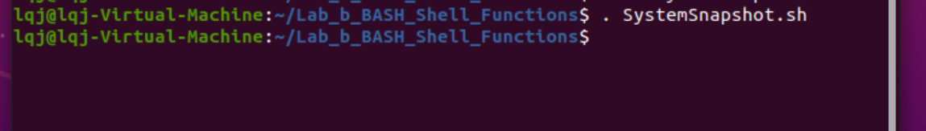

1. Try to run the function by typing the following command:

>>> snapshot

>>> clear

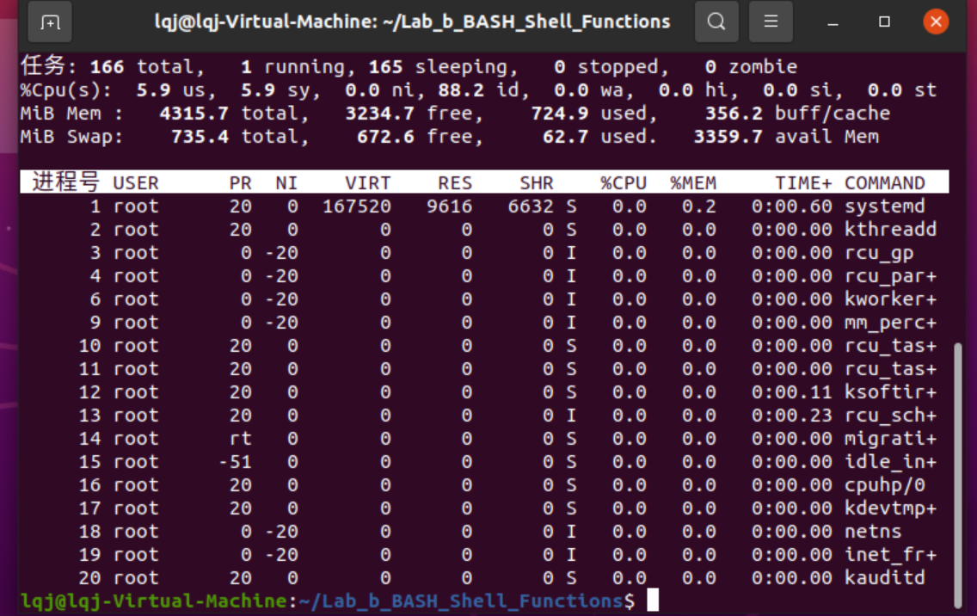

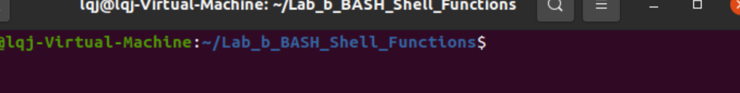

We run clear to clear the screen in order to see the file content later.

1. Run the following command to see file names in the folder:

>>> ls

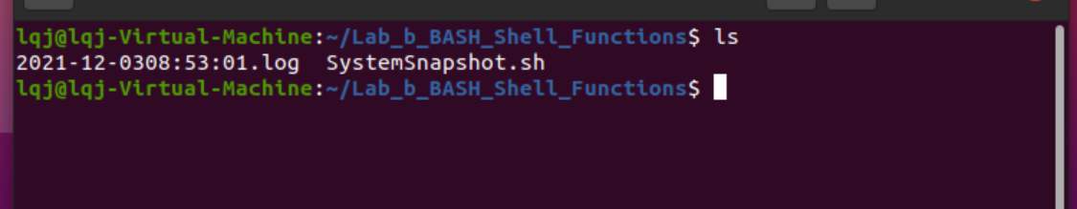

You will see a different file name because it was generated by the date and time you run the function.

1. Check the file content by typing the following command:

>>> cat 2019-07-1802:16:22.log

Note: you should change the file name to your own file name.

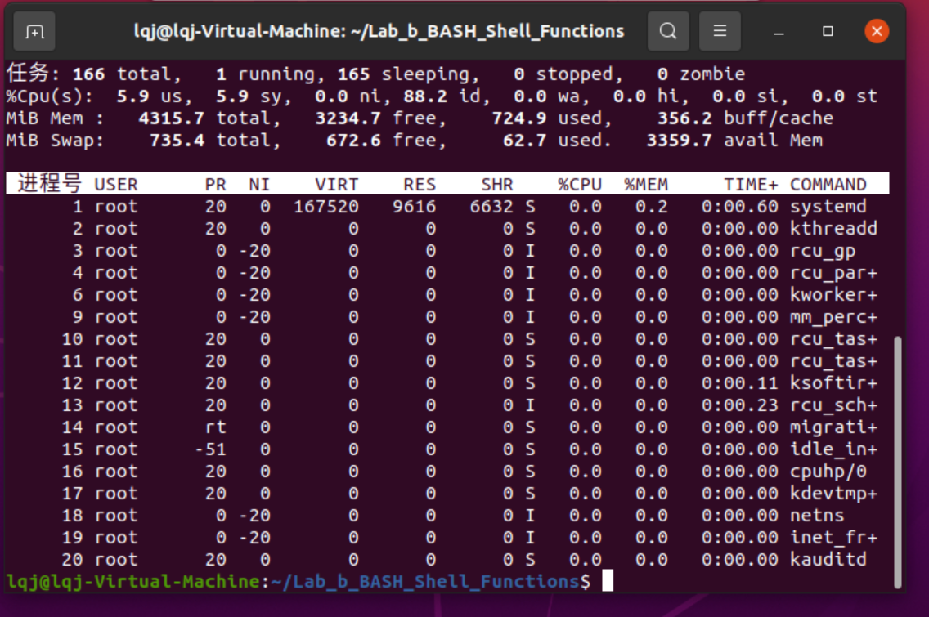

Lab Assignment Delivery Instructions:

* *Capture screen shots of your practice session results and paste* ***into this document accordingly****.*
* *Add/Replace the “demo” screen shots seen in this document with your results.*
* *Please elaborate as needed.*
* **Submission:**

Please submit to online. If that fails, email your results to: bangpanliang@gmail.com

The subject of the email should be: [Your StudentID, Assignment Name]